# Floor Manager

**Use Case Name:** QC check

**Participating Actor**: Floor Manager

**Entry Conditions:**

1. The Floor manager has logged in successfully and is displayed the Floor manager menu.
2. Work orders are flagged for a quality control check.
3. The QC check function is invoked.

# Flow of Events:

1. The QC check form is displayed by the system with a list of work orders flagged for QC
2. The Floor manager selects a work order that they want to test for quality control
3. The system opens a checklist which the floor manager can check off boxes for whether or not the work order product passes the QC check tests.
4. The Floor manager submits the QC checklist.
5. The system takes the floor manager back to the list of work orders to be checked.

**Exit Conditions:**

1. The Floor Manager clicks the exit button and the form closes.

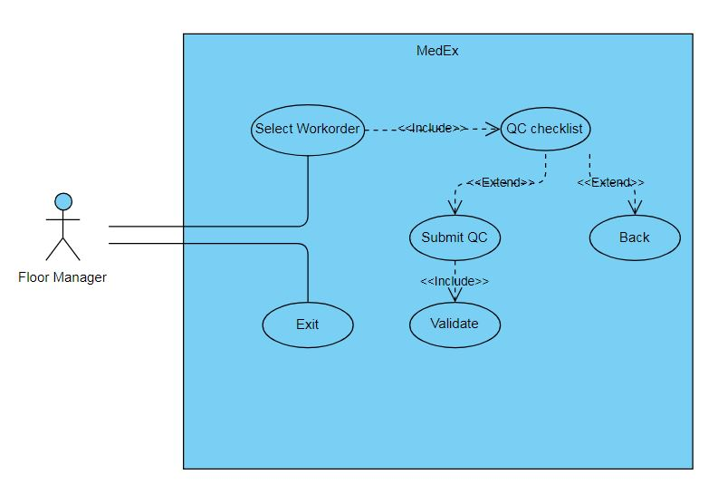

**Use Case Name:** Daily statistics

**Participating Actor**: Floor Manager

**Entry Conditions:**

1. The Floor manager has logged in successfully and is displayed the Floor manager menu.
2. The Floor Manager wants to check the production of the employees and stock usage.
3. The Daily statistics function of the system has been invoked.

# Flow of Events:

1. The system displays a form with three statistic options which the floor manager can choose from.
2. The Floor Manager selects an option
3. A chart opens displaying the statistics of the particular option.

**Exit Conditions:**

1. The Floor Manager presses the exit button and the form closes.

